Andrew Dykman – Lab 2

Task 1:)

- Top-down design, prototyping, waterfall

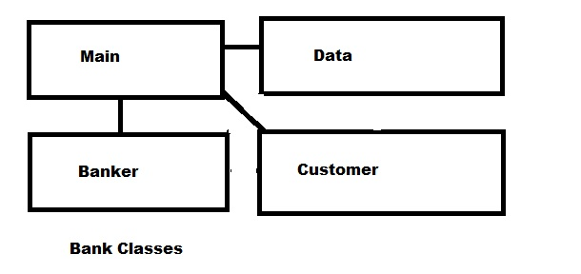
Each class inherits from and interacts with Main (which is also the interface)

Question A.) One
Question B.) No
Question C.) Yes

Task 2:)

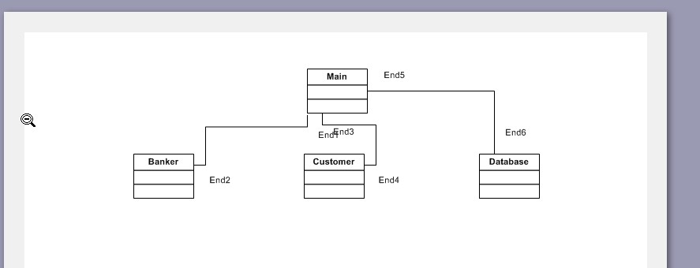
Question D.) Yes
Question E.) Yes
Question F.) Class Aggregations: Main to Banker, Main to Customer, Main to Database

